Hierarchical clustering

Consider the similarities between five data points:

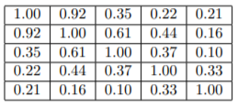

1. Cluster these five points using group average linkage. Draw a dendrogram to depict the clustering you obtain.
2. Cluster these five points using complete linkage. Draw a dendrogram to depict the clustering you obtain.